**HTML Tables**

**Problem 1. HTML Tables**

* Create Web Pages like the following using tables:

[](https://cloud.githubusercontent.com/assets/3619393/7002979/ae5d2178-dc5b-11e4-8a15-2d8a574ba5b9.png)

[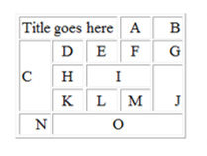](https://cloud.githubusercontent.com/assets/3619393/7002980/afb04c76-dc5b-11e4-917f-4e8fe696cf57.png)

**Problem 2. HTML Form**

* Create a Web Page like the following using forms:

[](https://cloud.githubusercontent.com/assets/3619393/7002981/b2a274b8-dc5b-11e4-9868-68675b7d328e.png)

**Problem 3. Calculator**

* Create a Calculator-like table. You should use a HTML 5 form for the Calculator.
  + Buttons for all the numbers and operators (+, -, etc.)
  + Textbox for the result

[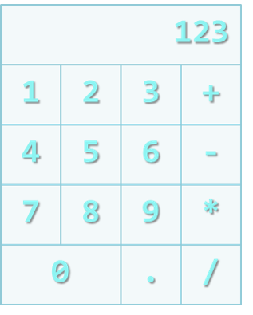](https://cloud.githubusercontent.com/assets/3619393/7002982/b3d1f3c2-dc5b-11e4-89ed-a3b2e52f32b9.png)

*Note: Do not make the same styles as the example*

*Note: Do not implement functionalities*